GS Drumline 2018-19

Legato Warmups
- Eight on a Hand (1,2,Knuckles)
- 8-8-16 (Reg, Dynamics, Accents)
- 16th Note Timing

Accent Warmups
- One-Handed Accents
- 5-7-10
- Triple Bucks
- FSU Bucks

Double and Triple Warmups
- Sanford Doubles
- Doubles II
- Singles and Doubles
- Milkshake

Triplet Warmups
- Triplet Dynamics

Roll Warmups
- Triplet Diddle
- Ones, Twos, Fours
- Roll Attacks (Duple, Triple)
- Singles

Cadences
- BSoD
- Gameday
- Cadence 2018

Stand Grooves
- Train
- Reverse Train
- Terminator
- DH
- Hack
- Shamarko Feet Work
- MC
- MRF
- No. 2
- Right Above It
- E5
- Gameday Feature
- DL2014

Cheers
- 1234
- Boom, Boom, Clap
- We Will Rock You
- Defense
- We Are GS

Covers
- Move, Shake, Drop
- Space Jams
- Wobble
- Shots
- Brown and Yellow

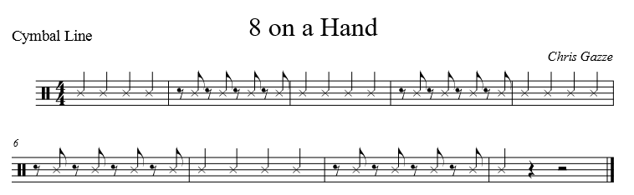

Rehearsal Notes
This exercise works on full rebound strokes, making it a perfect way to begin each practice session. Here are a few things to look for during your daily rehearsal:
- Work for a full, relaxed stroke (stick height = 12”).
- Work at a steady marching tempo. May start slow (mm=90) and work way up to a fast tempo (mm=140+).
- There should be no “stopping points” in the path of the stick as it travels up and down. The motion of the stick should be smooth on each stroke.
- Stick heights should match player to player.
- Keep the hand that’s not playing (the free hand) in the proper playing position.
- On the battery percussion instruments, allow the rebound of the stick off the head to push it back to the up position.
- May rehearse at different dynamic levels. For example, rehearse at a piano dynamic level (3”). At this height, the wrist will direct the stroke because of the decrease in the stick’s natural rebound. Strive for a full sound even at a low height, always keeping the wrist relaxed.
- Another option is to rehearse with a crescendo or diminuendo on each measure. Watch stick heights carefully. The height of the stick should consistently reflect the change in dynamics. Strive for an even, gradual change from low to high (or high to low).
VARIATIONS: Unison, Pattern 1 and 2 (same), Knuckles

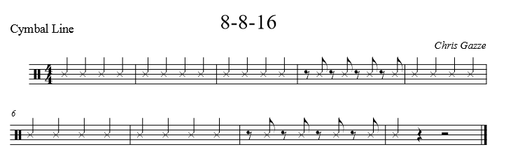

Rehearsal Notes
This exercise works on full rebound strokes, making it a perfect way to begin each practice session. Here are a few things to look for during your daily rehearsal:
- Work for a full, relaxed stroke (stick height = 12”).
- Work at a steady marching tempo. May start slow (mm=90) and work way up to a fast tempo (mm=140+).
- There should be no “stopping points” in the path of the stick as it travels up and down. The motion of the stick should be smooth on each stroke.
- Stick heights should match player to player.
- Keep the hand that’s not playing (the free hand) in the proper playing position.
- On the battery percussion instruments, allow the rebound of the stick off the head to push it back to the up position.
VARIATIONS:
- Unison
- Dynamics (Crescendo/Decrescendo)
- Accents

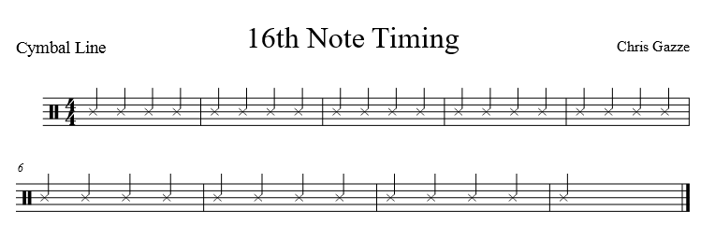

Rehearsal Notes
This exercise works on the accuracy of playing the four 16th/8th rhythm permutations. Here are a few things you should work towards when rehearsing this exercise:
- Start at a slow tempo, working with a metronome or play-along track.
- Marking time while playing the syncopated rhythms in measure 6 & 8 are occasionally problematic. If this is the case, first isolate one beat of the rhythm (plus a downbeat following) at a very slow tempo, then two, three, and finally all four. It’s often helpful for students to think of “playing their feet” on the 16th rest in the 4th measure.
- Snares/Tenors: There should be a constant motion on repeated strokes (right hand strokes in measure 2 & 4, left hand strokes in measures 3 & 6) – similar to the “8 on a hand” exercise. The hand playing one stroke per measure should freeze immediately after the stroke (LH meas. 2 & 4, RH meas. 3 & 6).
- Tenors: Play on one drum before playing as written.
- Cymbals: You may use this exercise to split parts with the various techniques while maintaining the downbeats.
VARIATIONS:
- Left hand leads
- Vary dynamic levels

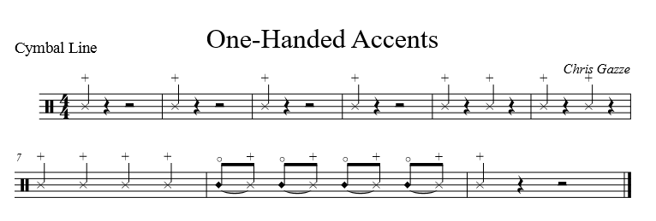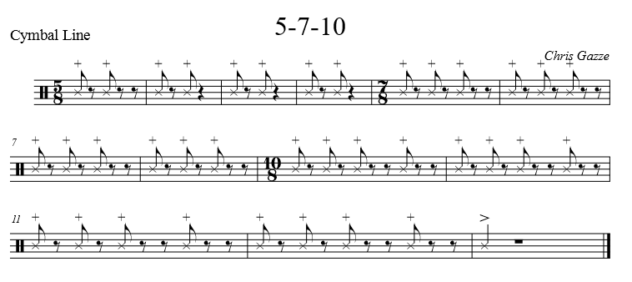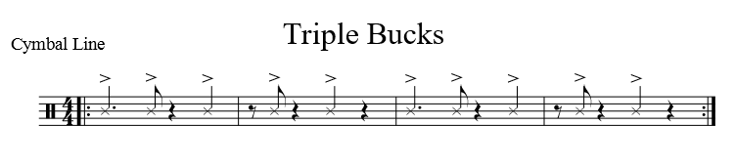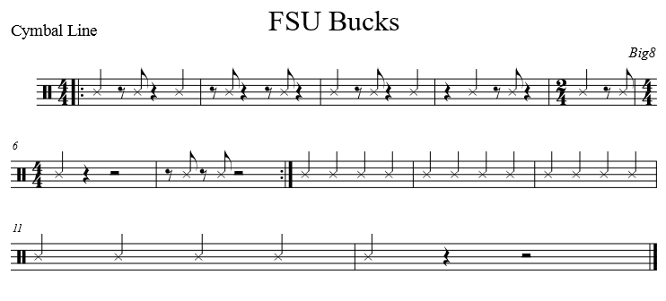

Rehearsal Notes
These exercises work on two height control. Here are a few things to look for during your daily rehearsal:
- Each accent stroke should be played at a full height (12”) with taps at 3”.
- While the velocity - or stroke speed - will increase, there should be no extra tension in the hand, wrist or forearm. Avoid trying to “hit the drum harder” on accented strokes.
- After the accent stroke hits the drum, “freeze” the stick in the down position (3”) by using a slight squeeze of the fingers and fulcrum. Only use as much squeeze as necessary to stop the stick from rebounding up.
- Play the unaccented notes at 3” with a wrist directed stroke into the drum. Strive to relax the hand, wrist and fingers on the soft taps. The taps, while soft, should be played with a full sound (play “into the drum” at a 3” height).
- Keep the hand that’s not playing (the free hand) in the proper playing position.
- Tenors: Play first time on one drum, then apply the written exercise the 2nd time through. Try to limit the amount of forearm motion when playing accents out on a different drum by allowing a slight side-to-side movement of the wrist.

VARIATIONS:
- One-Handed Accents
  - First time right hand, second time left hand
- 5-7-10
  - Play it split (Snares and Cymbals: 7-10-5, Tenors: 10-5-7, Basses: 5-7-10)
- Triple Bucks
  - Right hand first time
  - Left hand second time
  - RLRL with paradiddle last measure third time
  - LRLR with paradiddle last measure last time

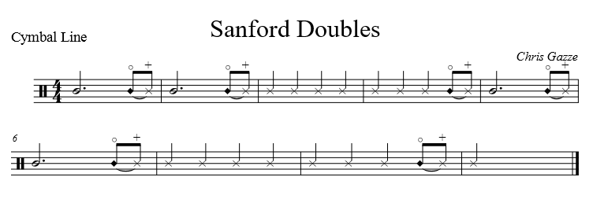
Rehearsal Notes
This exercise works on developing a quality double stroke – necessary for great sounding rolls. Here are a few things to look for during your daily rehearsal:

- The wrist directs each stroke with a relaxed rebound motion. Listen for evenness of sound. A wrist that is too tight will result in a choppy sounding double stroke. A “bounced” double stroke will result in the first stroke being louder than the second. Think of this as you do the “8 on a hand” exercise – but “2 on a hand” instead.
- Isolate the motion to the wrists as much as possible (no large forearm motions for the beginning of each double stroke).
- Tenors: Practice on one drum first, then play the exercise as written.
- Bass Drums: Play the exercise in unison first, then as written. Split the 16th notes between right and left hands.

VARIATIONS:
- Sanford Doubles
  - Play the entire exercise on one hand.
  - Play exercise as all double stops, checking that the stick motion from left to right is the same.
  - Play exercise at different heights
  - Left hand lead
- Triplet Dynamics – no written parts
  - Snares, Tenors (one drum), and Basses play unison triplets. Cymbals play hi-hat downbeats.
  - Follow the lead of the instructor for dynamics and accents.

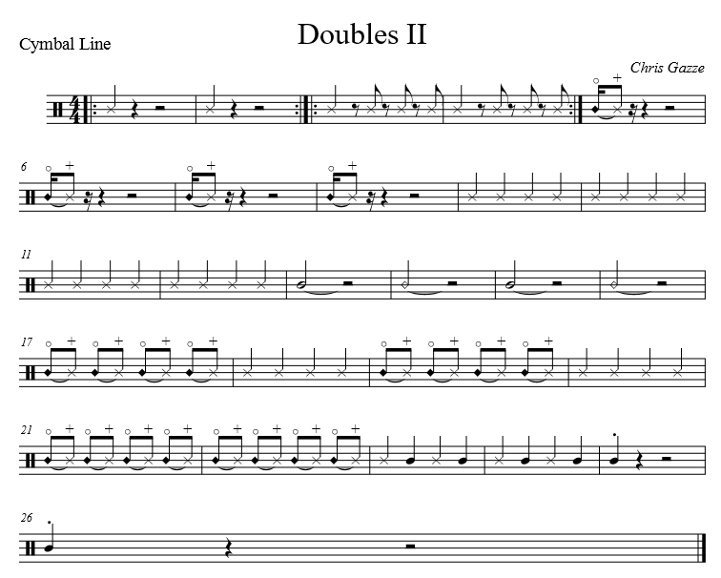
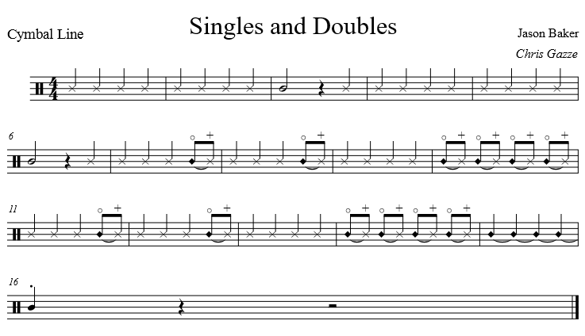

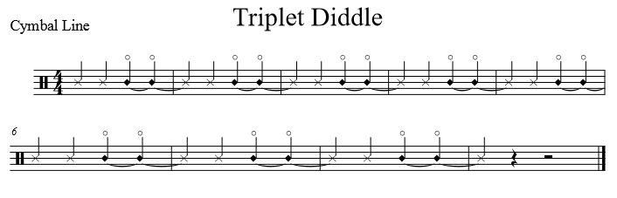

Rehearsal Notes
This exercise works on triplet roll patterns. Here are a few things to look for during your daily rehearsal:

- Snares/Tenors: This exercise is a roll technique exercise with a triplet base.
- Play at a consistent 6” height.
- Even though the pattern moves from “hand to hand” on each beat, strive for a consistent sound without pulsing each downbeat.
- Tenors: Practice on one drum before playing the written exercise
- Bass Drums: All notes should be alternated (RLR). Listen to the snares and tenors to match note spacing.
- Cymbals: This exercise incorporates sizzles. Be sure to carry it out through the entire note. These parts may be split.

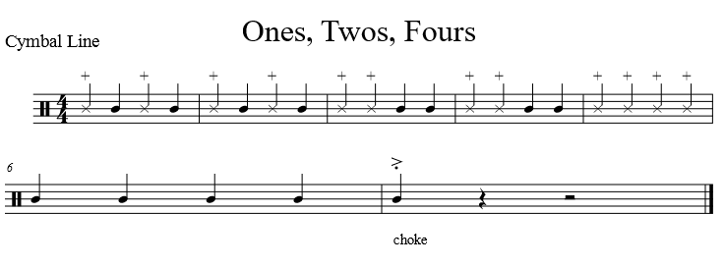

Rehearsal Notes
This exercise works on 16th note roll patterns. Here are a few things to look for during your daily rehearsal:
- Snares/Tenors: Play the first 2 measures at a consistent 6” height. The 16th check and the roll should maintain a consistent motion and height from one to the other – and a consistent feel in the hands (don’t overly relax for the 16ths or squeeze for the roll).
- You may add accents on the 16th notes on the downbeat and a right before the roll pattern. Measures 3-4 should be played at 9” for the accent, 3” for the taps and rolls. This presents the same control issues as the Accented 16th exercise. Work to keep the roll at the 3” height, but with a full sound (by playing “into the drum”).
- You may crescendo at the end of the last measure. Start at 3” and finish at 9”. Keep the tempo and hand speed consistent throughout. Avoid “ripping the roll” (by speeding up) or “hanging the roll” (by slowing down).

VARIATIONS:
- Play Roll Attacks Duple and Triple versions.
- Vary tempo of exercises.

